Zero-Trust Key Vault: When "Access Denied" Is the Whole Point

What is Azure Key Vault, and why does it matter?
All applications have secrets that they cannot avoid having. They include database connection strings, API keys, TLS certificates, credentials to communicate with other services. The easier approach and one that inadvertently leads to many security breaches out there involves distributing these secrets to config files, environment variables, and scripts, including somebody's personal laptop. Azure Key Vault was developed precisely for this purpose.
It is an integrated solution for securely storing and managing secrets and access to them. Rather than coding a password somewhere in an application or by a developer, Azure Key Vault is accessed at run time. Each request from Azure Key Vault is authenticated, and access authorization can be limited to particular permissions and logged.
That is itself an important step forward from random secrets. Yet the vault is only as strong as the things that can get to it. Set one up with the default configuration, and it is still a service that is available on the internet and accessible from anywhere in the world as long as the person has the proper credentials. The deeper question that defense in depth poses is whether this vault is even supposed to be accessible from the public internet at all.
That question is what this project set out to answer, concretely, not theoretically.

The Project
This is a specific form of security architecture that is easy to summarize in one sentence and difficult to prove: "there is no public door on the vault". Anyone can make such a statement. Screenshot of a toggle set to "Disabled" is cheap. More challenging – and much more convincing – would be proof of the very point where the outsider is refused network access, shown next to the very point where a legitimate application successfully accesses the system using only private resources.
This was the actual objective. Not "Is it possible to make the Key Vault private" – Microsoft's documentation answers that question. Objective was to build a real multi-layer system (a web application, a network, and a vault) and make the Zero Trust claim provable, not just configured.
The architecture itself is surprisingly simple to state: a virtual network designed for two specific functions in two subnets, an App Service that requires secrets, a Key Vault refusing to communicate on the public internet, and a Private Endpoint serving as a single connection point between them.

Architecture
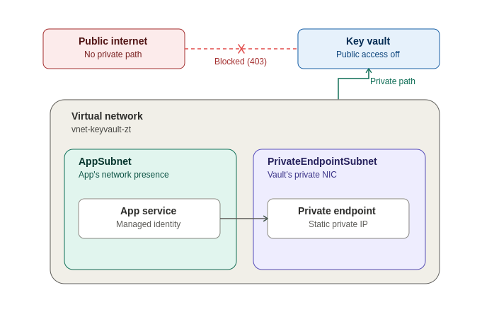

The virtual network includes two subnets performing two different roles: one is AppSubnet, where the App Service has its own external network reachability, and the other is PrivateEndpointSubnet, which is exclusively used for the network interface of the private endpoint created for the Key Vault in the virtual network. The App Service is completely connected to the Private Endpoint using the internal connection through VNet Integration. At the same time, the Key Vault doesn't have any connectivity to the external network; its access is fully blocked.

Building on Open Ground First
A network without any controls and a vault without a door for anyone to get in is a great setup up until the moment you realize that you have also excluded the means to develop the rest of the system. Therefore, this project started with planned and intentional openness – a good starting point for further development.
It started with the network. The first step included creating a virtual network that would contain two subnets mentioned above. The separation was not just some kind of a visual trick – mixing the traffic of an application and the private endpoint of a resource within one subnet is possible, yet dividing them makes the idea behind the architecture clear.

Next was the vault, intentionally kept wide open. Key Vault was built using the modern Azure RBAC permission system, and, importantly, with public network access enabled. It was not an accident but a step taken intentionally in order to demonstrate that the vault works properly, that a test secret could be stored there and retrieved, prior to adding any restrictions that may mask whether some subsequent failure is genuine or just a wall working prematurely.

Finally, the application that was going to require all of the above. A Web App deployed and running inside an App Service Plan (Basic tier – the cheapest that actually allows for networking capabilities required for this particular project).

Giving the Application a Path In — Without Giving It a Reason Yet
VNet Integration connected the App Service into AppSubnet, giving it a legitimate network presence inside the virtual network rather than existing purely on the public internet. With Route All outbound traffic enabled, this wasn't cosmetic — it meant the app's traffic would genuinely prefer the private network path once one existed to prefer.
But a network path alone doesn't grant permission to anything. That's a separate question, and answering it correctly was the next piece of the build.

Proving Identity Before Introducing the Network's Real Complexity

Even before the vault’s door had been shut, the process paused long enough to demonstrate one final point – namely, that the app itself had permission to use the vault, regardless of how it accessed it.

The Azure App Service had a system-assigned managed identity created for it – an identity without a person behind it, without any sort of storage in a configuration file, and without requiring anything to be entered manually by anyone. This identity was then assigned the Key Vault Secrets User role within the Key Vault – the same idea of minimal permissions as before: access to the secret, no more.

Having done that, a reference to the Key Vault was added straight into the Azure App Service’s configuration, where it was asked to resolve a secret from it at runtime. It worked – demonstrated simply with the presence of a green checkmark besides the source of the setting in question: an identity with narrow permissions, accessing a genuine secret, all with the public-facing vault door wide open.

This would be vital for what would follow. No matter what happened when the network was sealed off, there would be no uncertainty around success and failure. The identity had already been proven. Only the network access was now in question.

Building the Private Road

With the baseline completed, it was time to move to the Private Endpoint component which was deployed into PrivateEndpointSubnet to ensure that the Key Vault receives the actual private IP residing within the virtual network.

The use of the private IP was dependent on another component called a Private DNS Zone: privatelink.vaultcore.azure.net that was tied to the virtual network and had a record mapping the public hostname of the vault to the private IP. That is what turns all the infrastructure invisible for the app as the App Service does not require any special logic to "take the private path" as it just references the vault by its regular hostname and the network resolves the mapping through DNS services.

The Moment the Door Actually Closes

Disabling access to the Public Network on the Key Vault had a disproportionate importance despite its seeming simplicity. Everything up to that point was about preparations. But that moment marked when the project’s fundamental premise turned from a theoretical statement into a reality. In the following steps, there will be precisely one route into the vault, and it will be possible only via infrastructure constructed by the very project in question.

One particular point is worth highlighting here explicitly: Key Vault provides the feature to allow some "trusted Microsoft services" to access the vault bypassing the firewall in case the public access is disabled. This feature does not apply to the current architecture. The said feature can be used with a vault that has public access disabled but with an allowed list of IPs. In this case, public access is not just limited but completely disabled. And there is no longer any possibility to provide an exception from the rule. Moreover, it is not needed because App Service will not ask it to do anything anyway.

Two Proofs, Not One Assertion
Only an attempt and a denial can prove the meaning of the closed door; likewise, the proof of a door open to someone who rightfully has permission proves just as much.
In the first test, I sought deliberate failure. I tried to access the vault from my laptop directly, from outside the virtual network, requesting access to the secret. And I got precisely the failure I should have: a denial at the level of the network, not of permissions; a rejection from a vault that no longer even listens for connections at all on the public internet.
In the second test, I tried to succeed, the same as before. Checking again in the App Service's configuration, I found that the vault reference resolved — and yet, despite the re-permissioning, nothing had changed. This time, the app still referenced the secret because it had never needed the public internet to function in the first place.
Placed together, the two proofs reveal that it was never even a diagram — it was an architecture that could be proven: an outside attempt, denied flat out, at the network layer. A proper application, accepted without fuss, using infrastructure that never once relied upon a wide-open internet. The same vault. The same secret. Two completely different results, based entirely on how they were requested.

The Build, Step by Step
- Create the virtual network with two subnets: AppSubnet and PrivateEndpointSubnet. Ensure to give the subnets separate, non-overlapping range of IPs
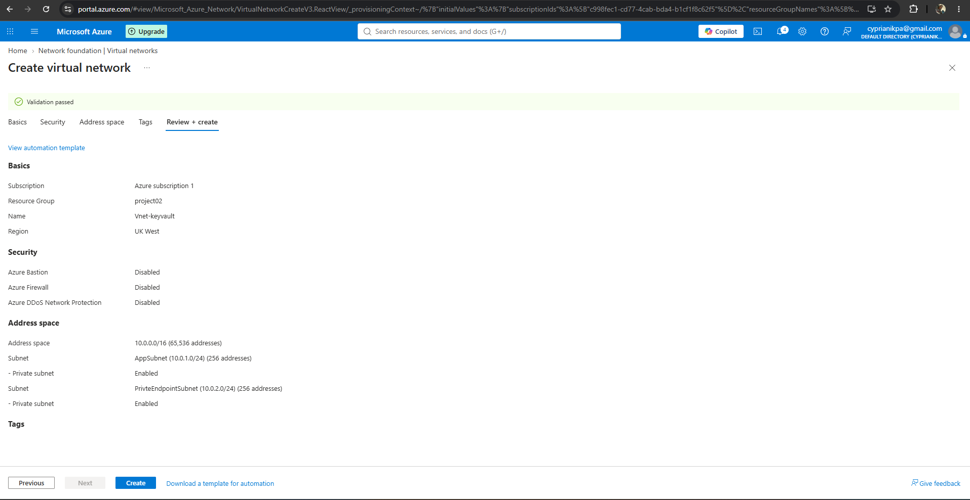
- Create the Key Vault using the Azure RBAC permission model, with public network access left enabled as a baseline. Add a test secret.
- , search 'Key Vault' and click '+ Create'. Use the same resource group as your VNet, give it a unique name (e.g. 'kv-zt-yourname'), pick the same region as your VNet, and leave Pricing tier as Standard.
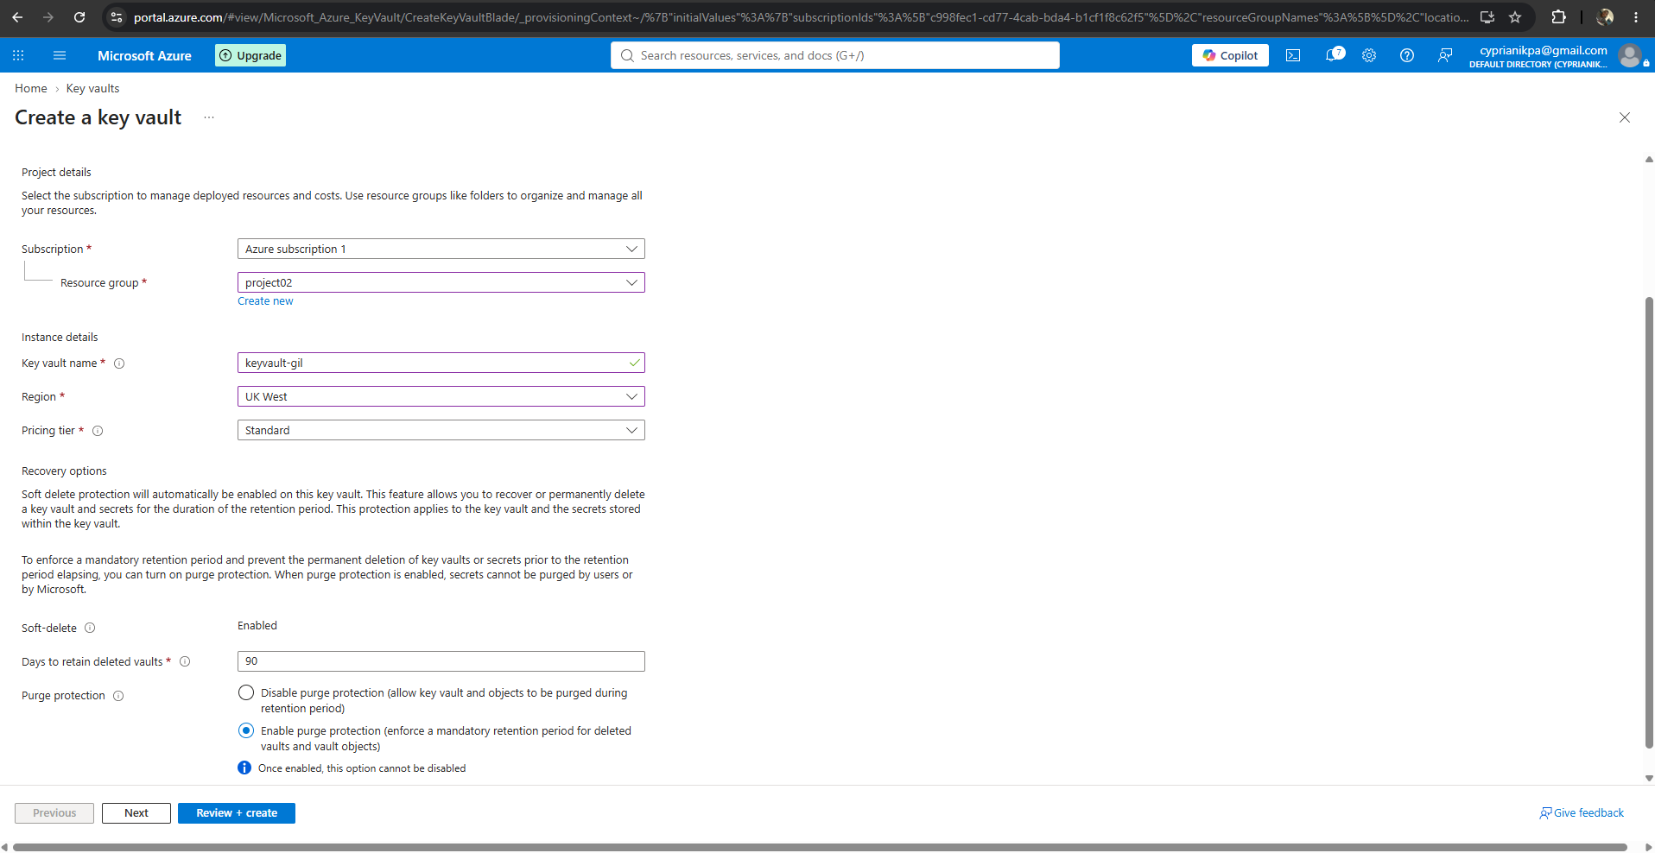
- Choose the Azure RBAC permission model : On the Access configuration (or Basics) tab, select 'Azure role-based access control (RBAC)' as the permission model, same as before. Leave the 'Resource access' checkboxes (VM deployment, ARM template deployment, Disk Encryption) unchecked — none apply here either.
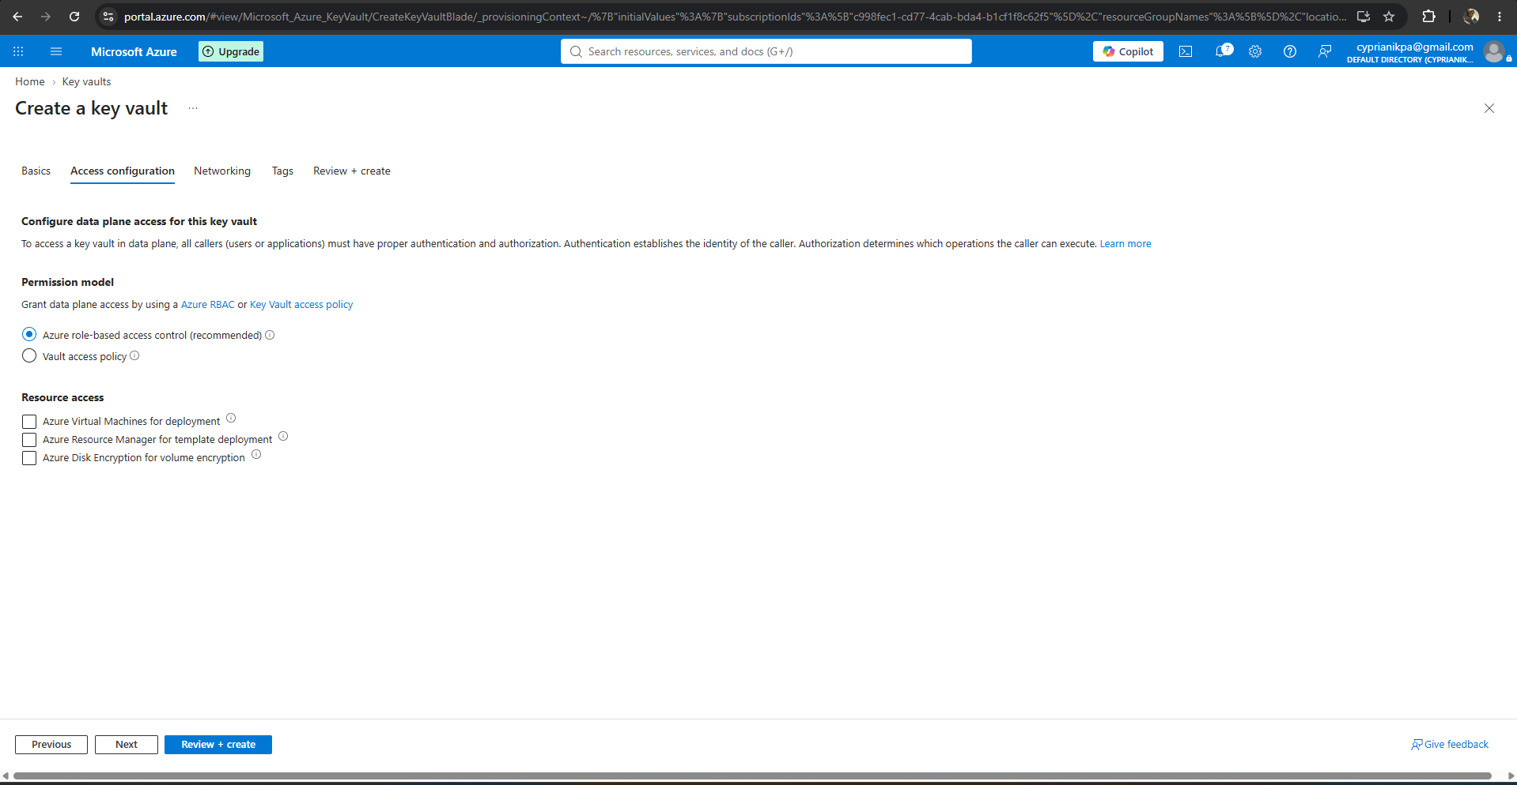
- Go to the Networking Tab. Leave 'Enable public access' turned ON for now, with the default action set to Allow.
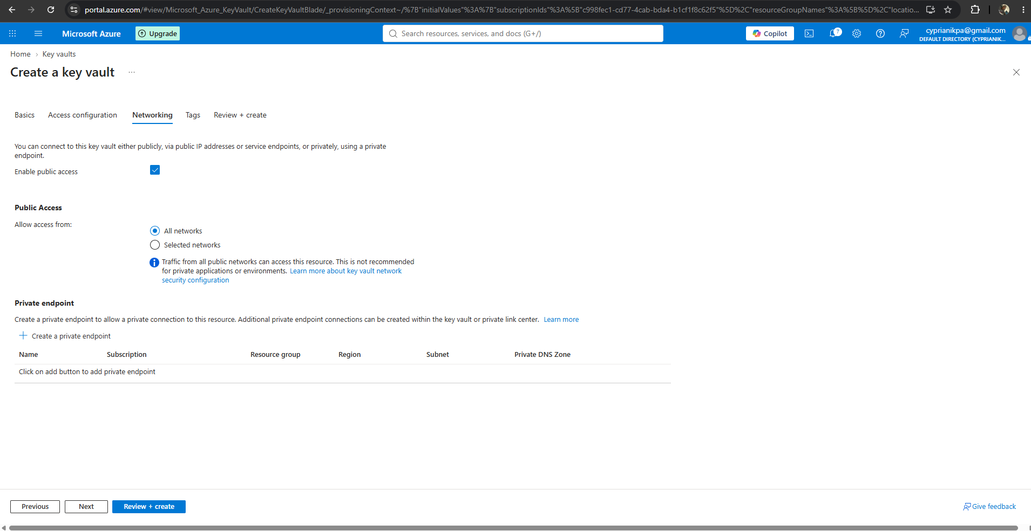
- Review, create, and deploy
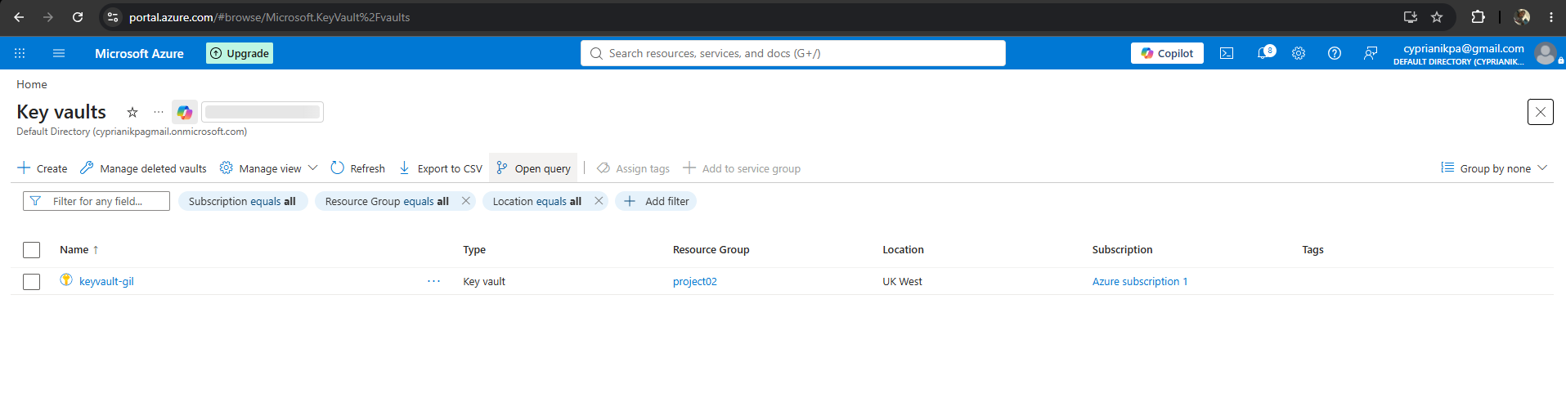
- Grant yourself the Key Vault Administrator role and confirm you can read the test secret back.
- In the Vault left menu, go to the Access control (IAM) > Add > Add role assignment. Search for ‘Key Vault Administrator’, select it.
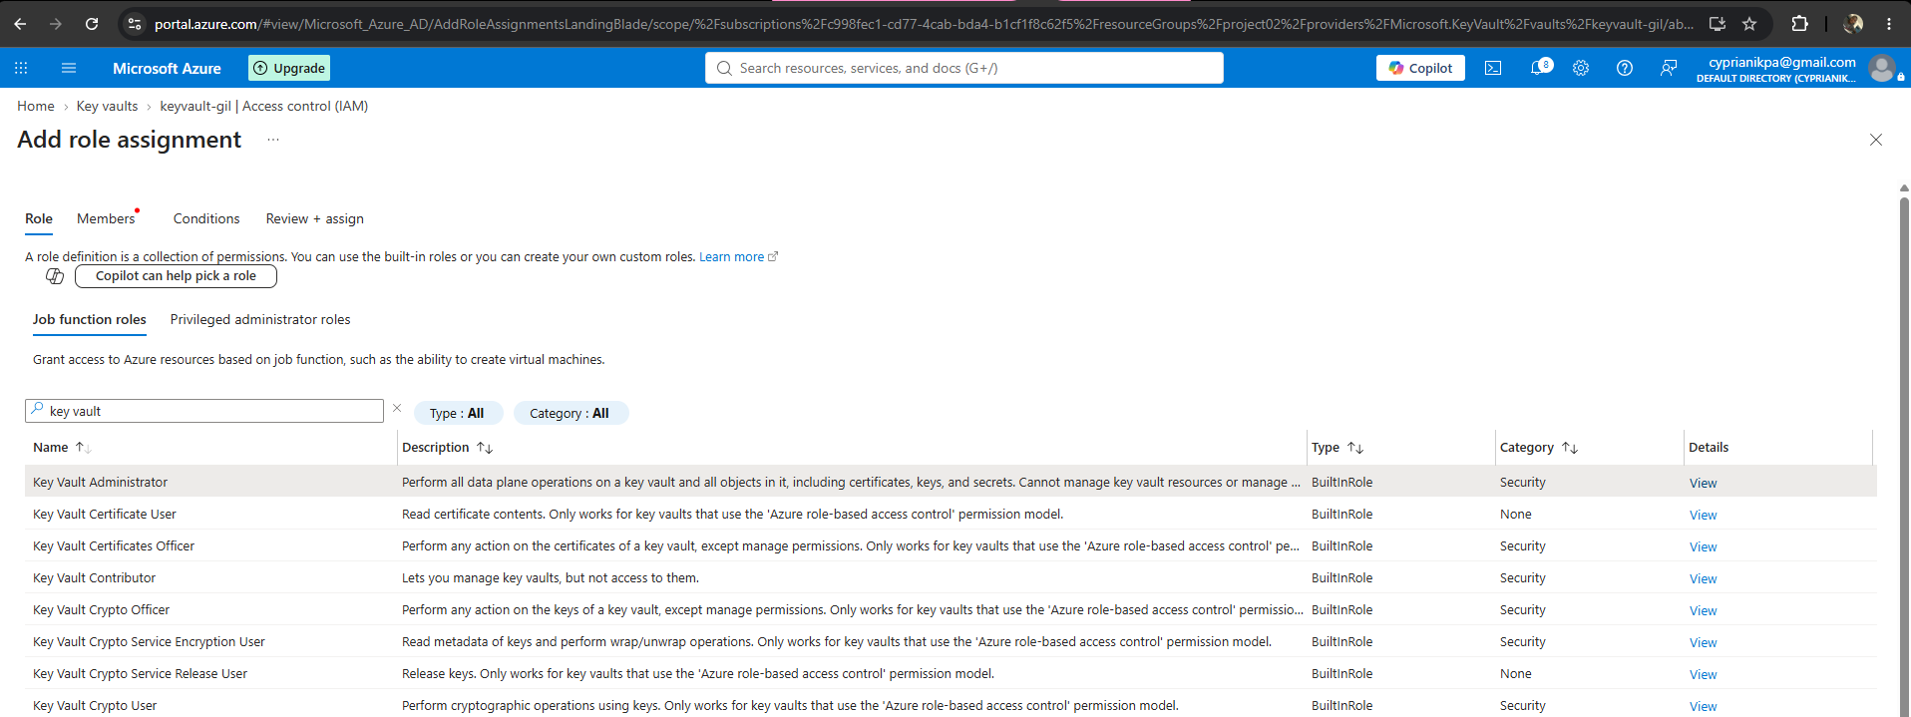
- choose your own account under members, and review + assign. This lets you manage secrets from the portal.
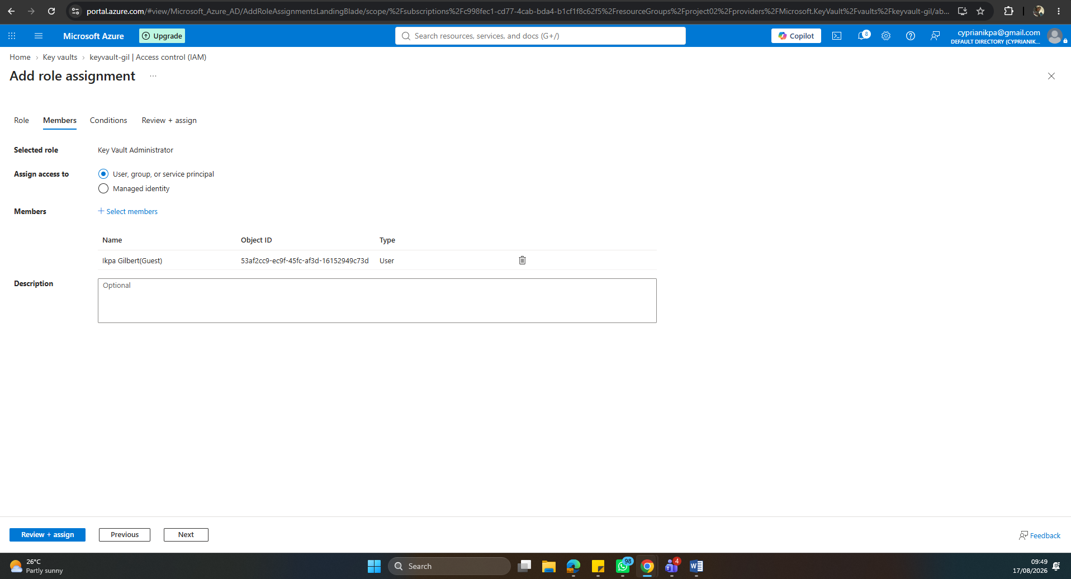
- Add a test secret: Go to Objects > Secrets > + Generate/Import. Name it and give it a placeholder value like, and Create
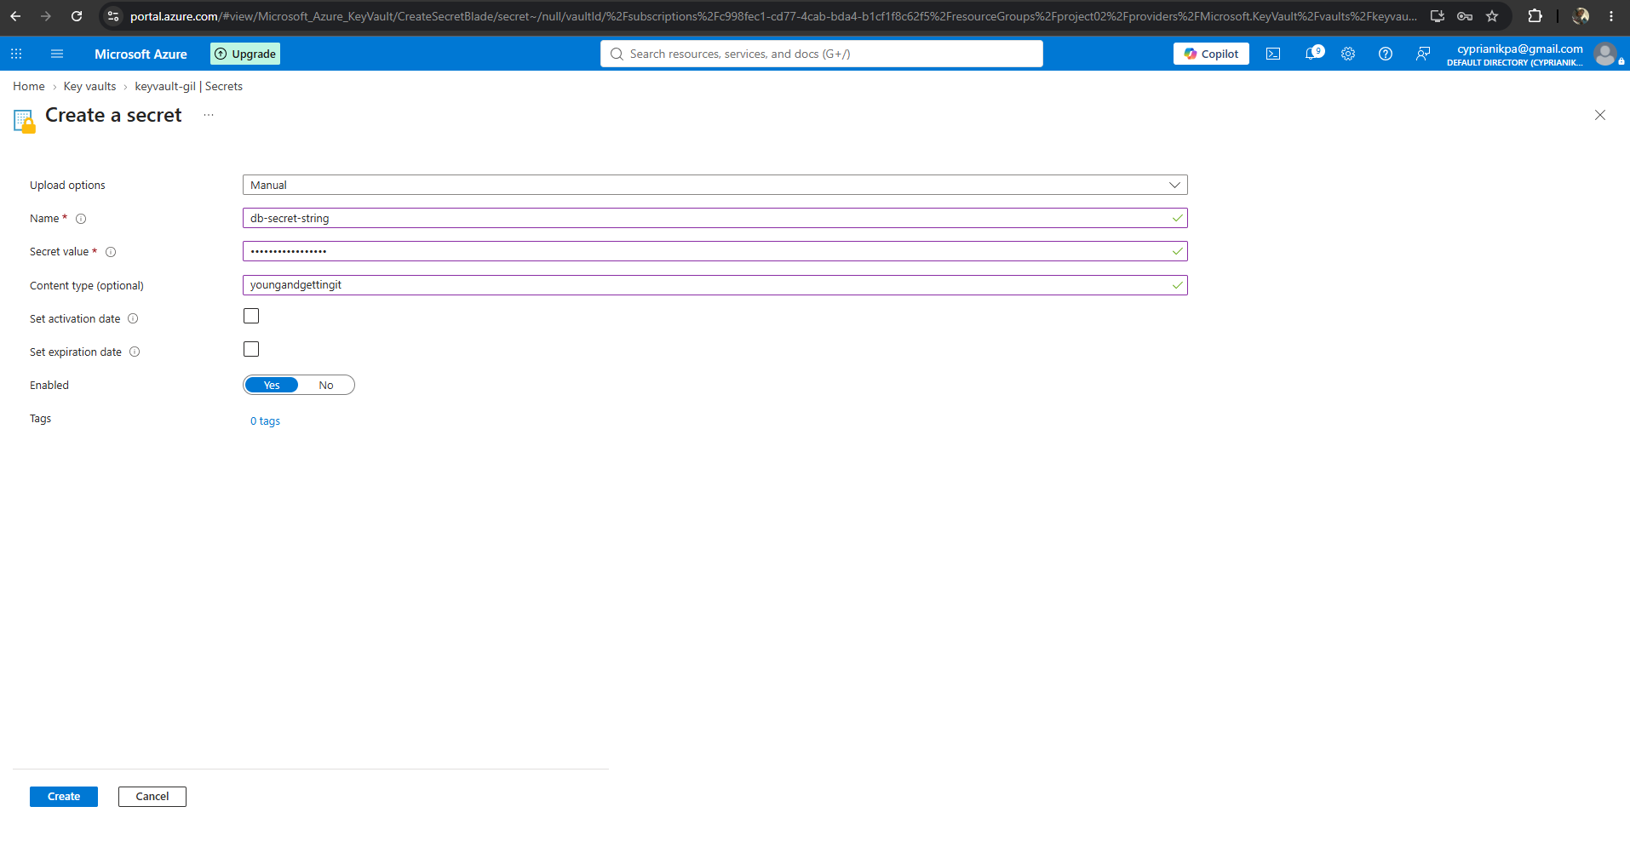
- Confirm you can read the secret back: Click into the secret and confirm you can view its value. This proves the vault, your role, and the open network path are all working.
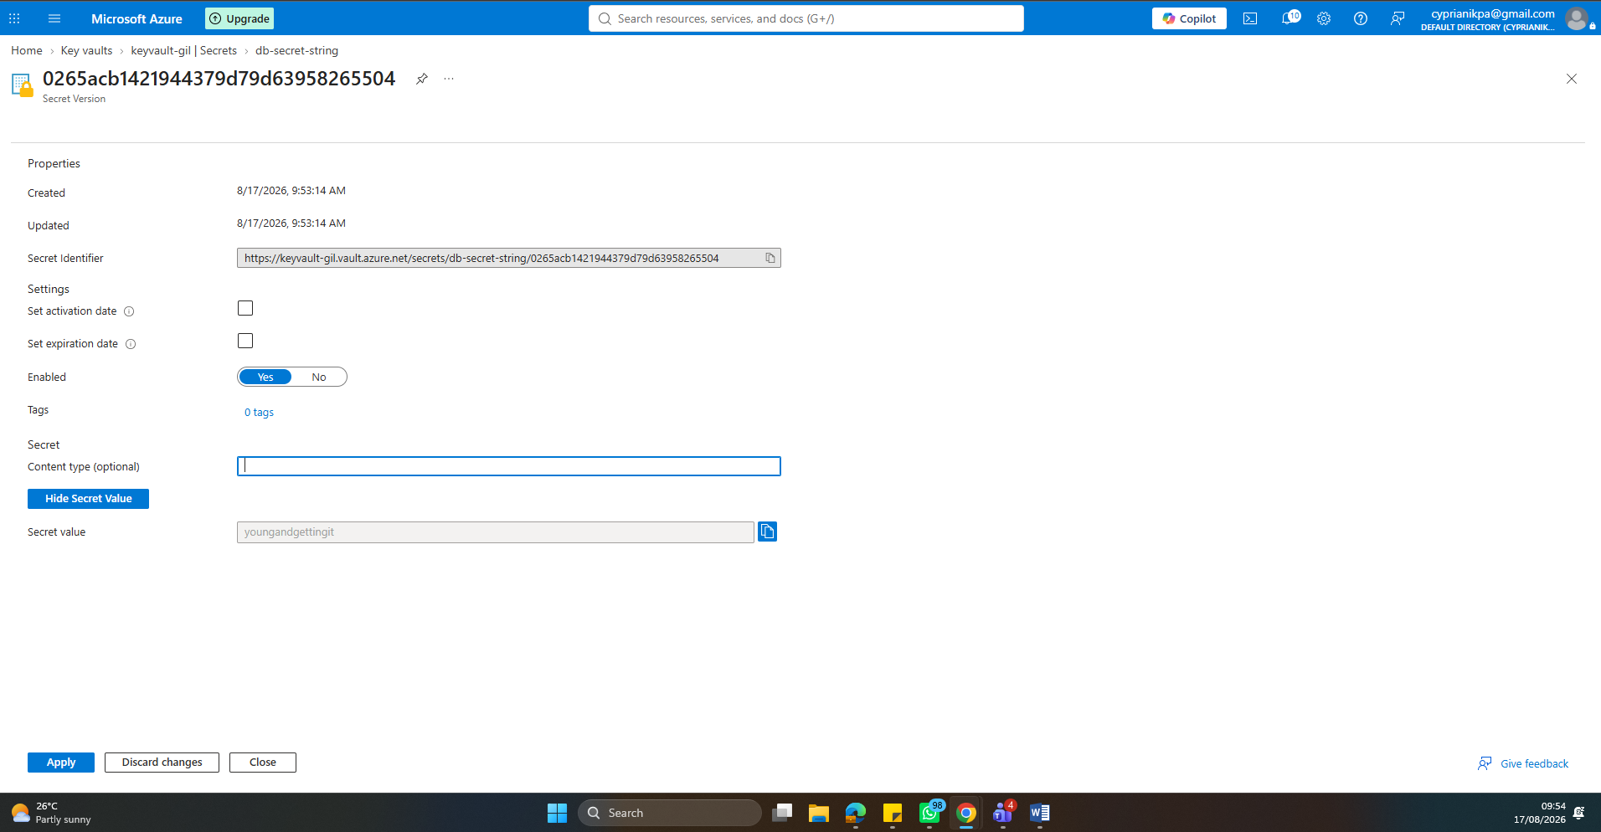
- Create an App Service Plan (Basic B1) and deploy a Web App to it using the minimum tier that supports VNet Integration.
- search 'App Service Plan' and click '+ Create'. Use the same resource group and same region as your VNet and Key Vault. Give it a name like 'asp-zt-project'.
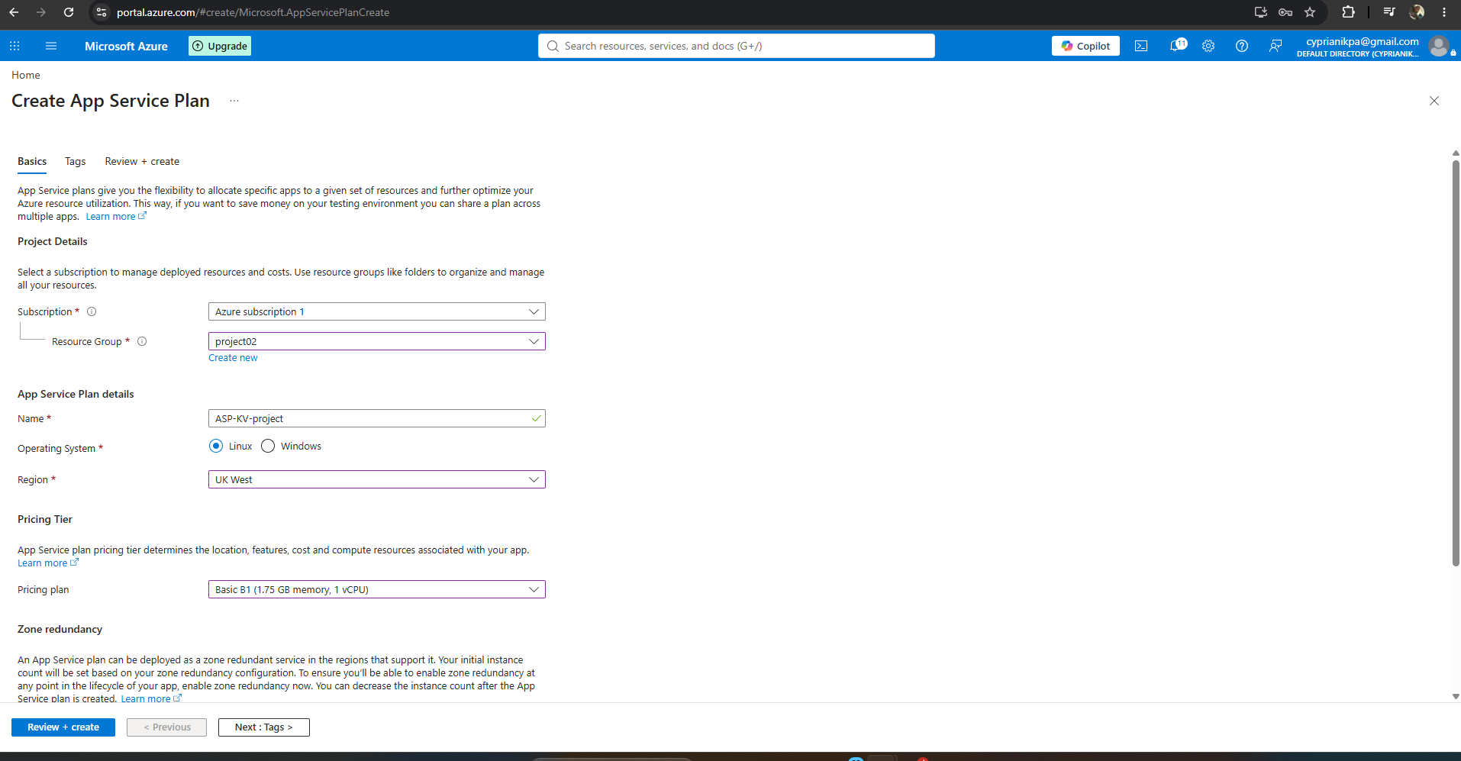
- Create the Web App (App Service): Once the plan is deployed, search 'App Service' > '+ Create' > 'Web App'. Use the same resource group, give it a globally unique name (this becomes part of its public URL).
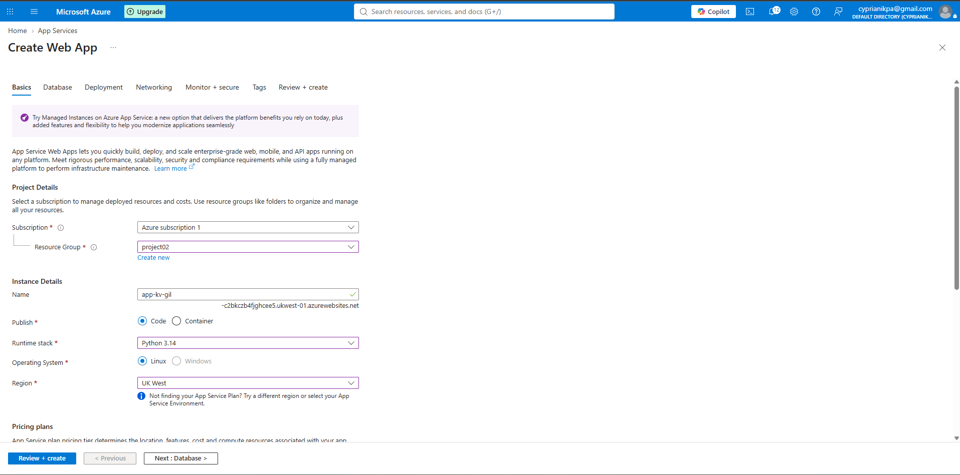
- pick a runtime stack (e.g. Node.js, Python, or .NET — whatever you're comfortable with, since this is just a demo app), set the same Linux/Windows OS as your plan and attach it to the app service plan you just created.
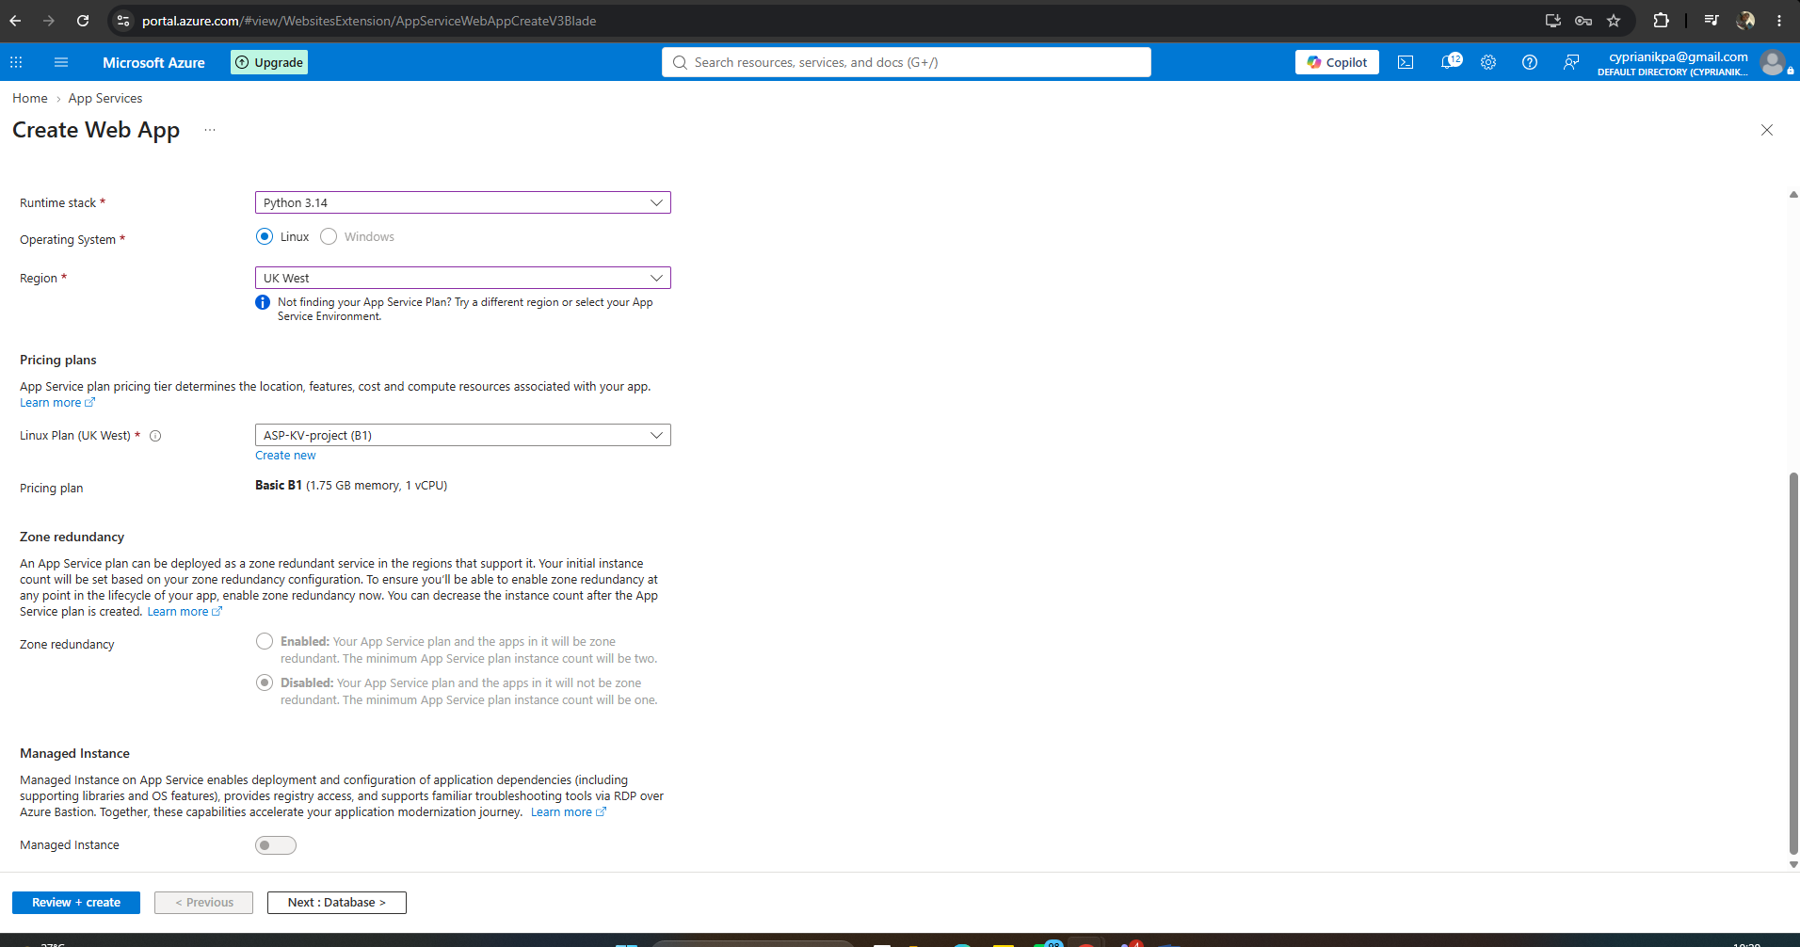
- Deploy and confirm it's running
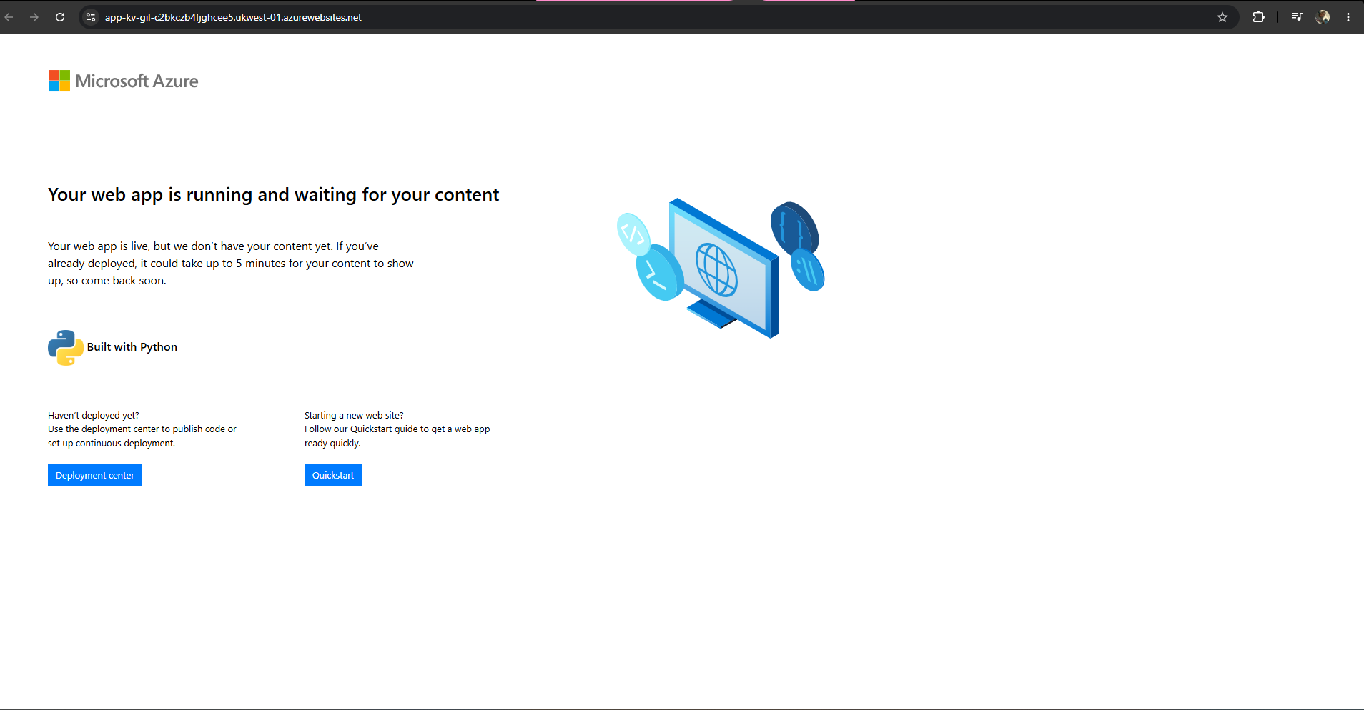
- Connect the App Service to AppSubnet via VNet Integration, with Route All enabled for outbound traffic.
- Open the App Service Networking blade. Find the VNet Integration option under ‘Outbound traffic configuration.
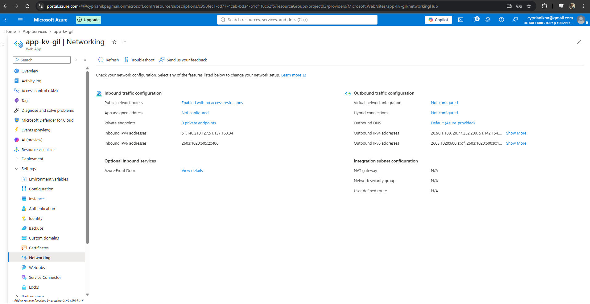
- Select your VNet and for the subnet select 'AppSubnet' not PrivateEndpointSubnet, since that one is reserved for the Private Endpoint in a later step.
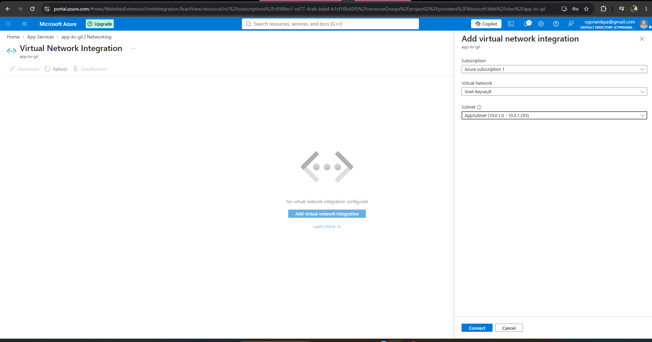
- Verify the integration shows as connected
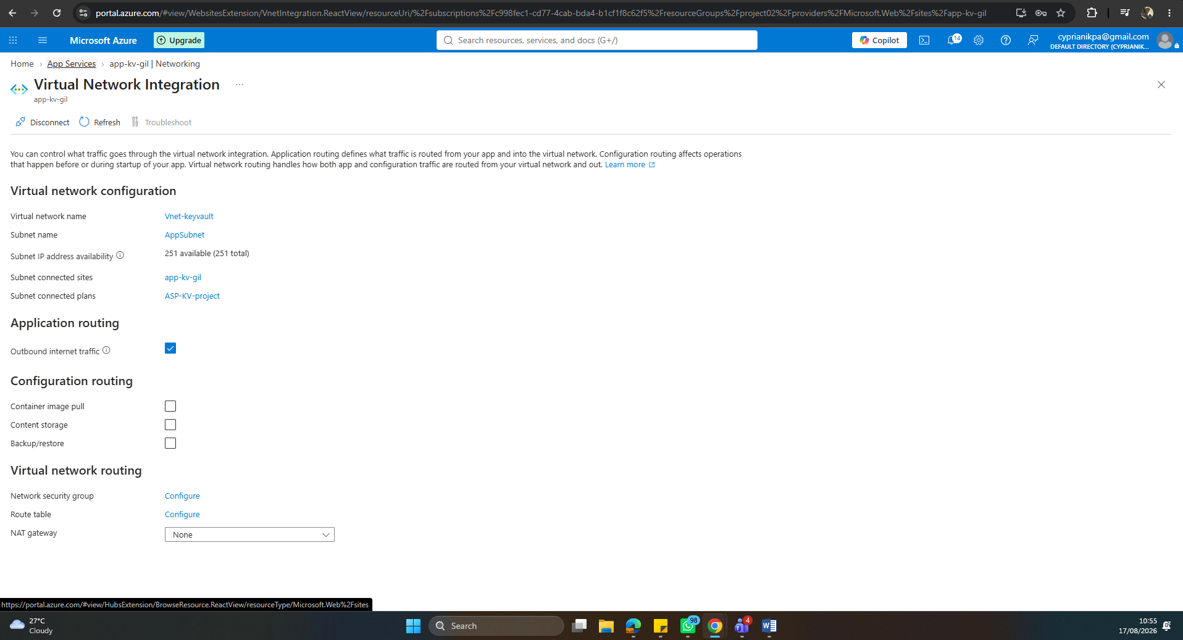
- Enable a system-assigned managed identity on the App Service, and grant it the Key Vault Secrets User role.
- In your App Service's left-hand menu, go to 'Identity' (under Settings). Under the 'System assigned' tab, toggle Status to 'On', then click Save and confirm when prompted
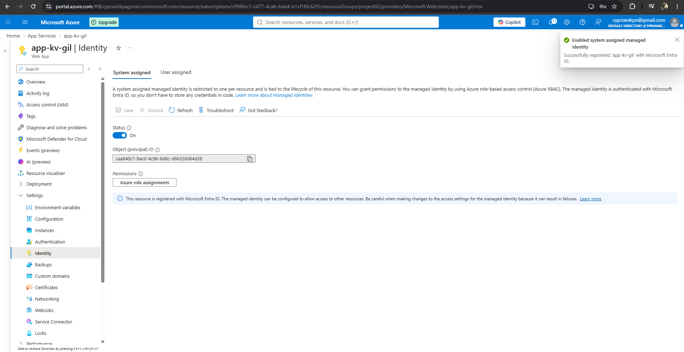
- Go to your Key Vault > Access control (IAM) > Add > Add role assignment. Search for and select 'Key Vault Secrets User, then assign it to the app itself.
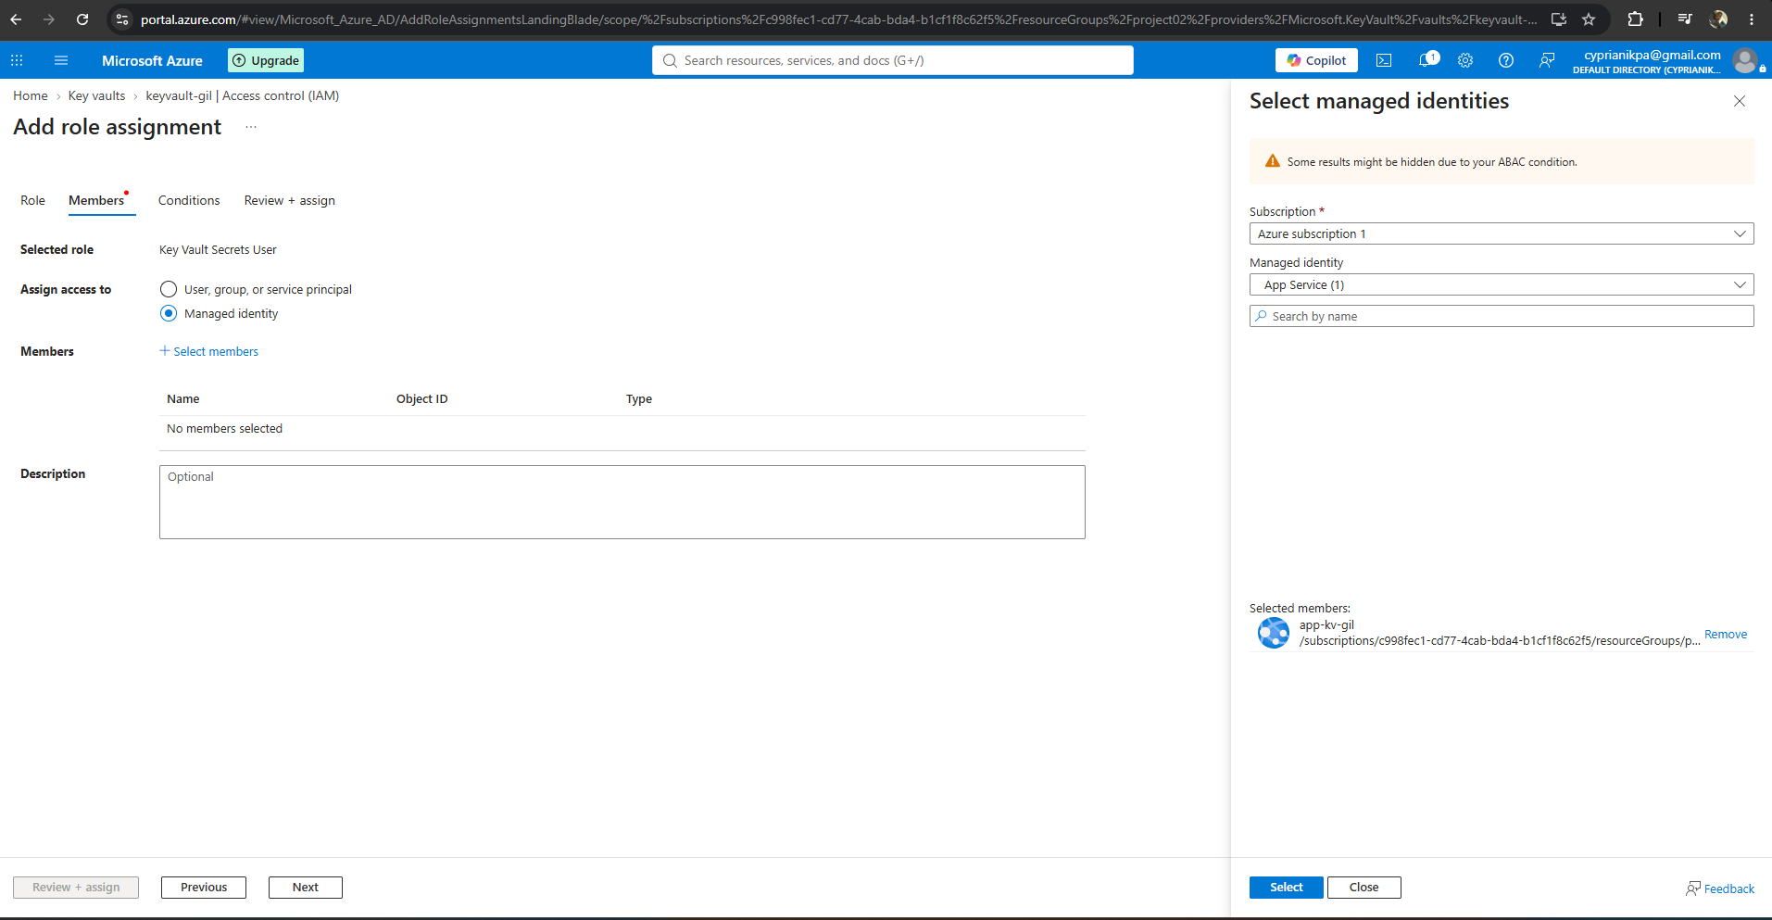
- Ensure to always confirm the role assigned in the Role Assignment page
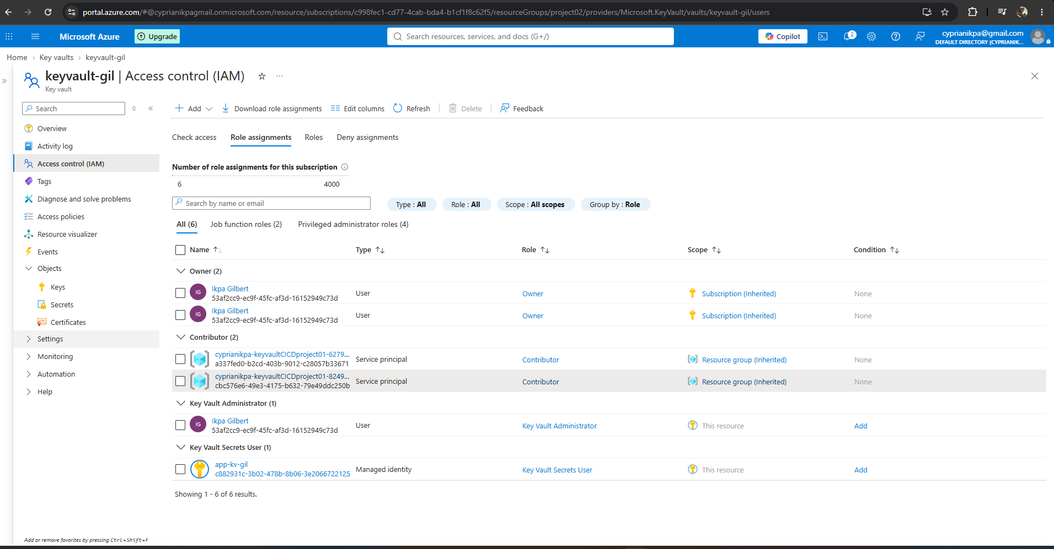
- Add a Key Vault reference as an App Setting, and confirm it resolves successfully — proving identity and code path work while the vault is still open.
- In your App Service > Settings> Environment Variables> Application Settings, add a new setting to reference the secrete using Key Vault reference syntax, e.g Name: 'DbsecretstringConnection', Value: ‘@Microsoft.KeyVault(VaultName=keyvault-gil;SecretName=db-secret-string)' Click OK, then save at the top and confirm. App Service will resolve. This automatically at runtime using the managed identity you just set up.
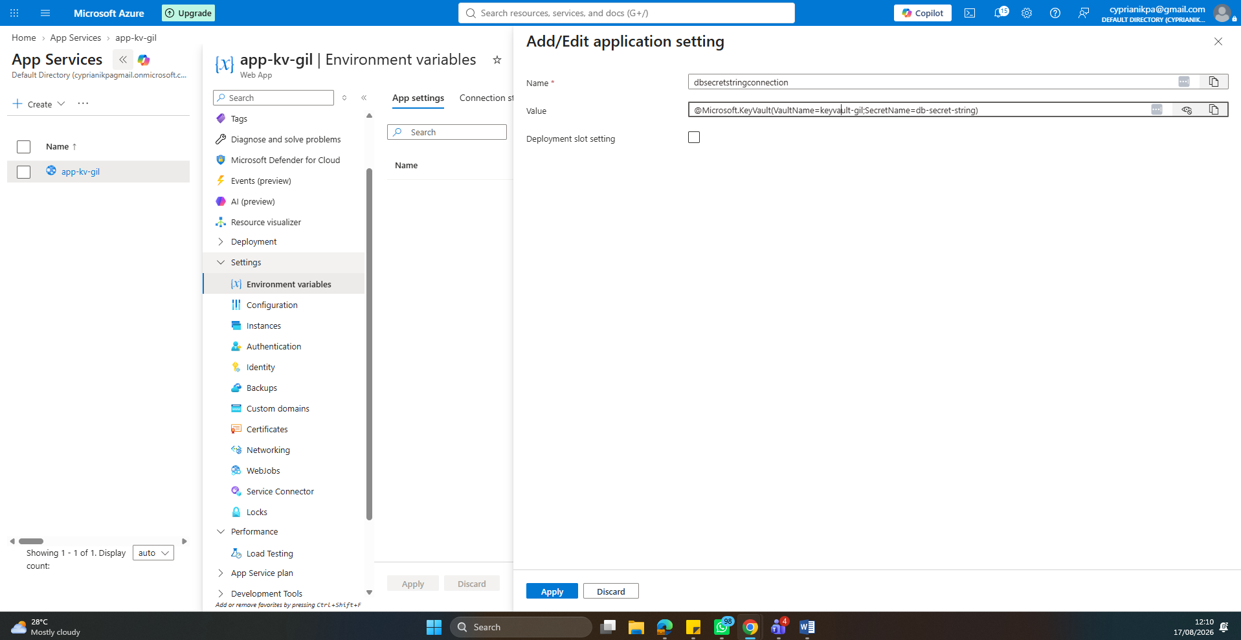
- Verify the reference resolved successfully: Back in Configuration > Application settings, look at the 'Source' column next to the setting you just added. If it shows a green checkmark with 'Key Vault Reference', the app successfully resolved the secret through its managed identity — over the public path, since the vault is still open. If it shows an error/red icon instead, double-check the role assignment and the exact vault/secret names in the reference string.
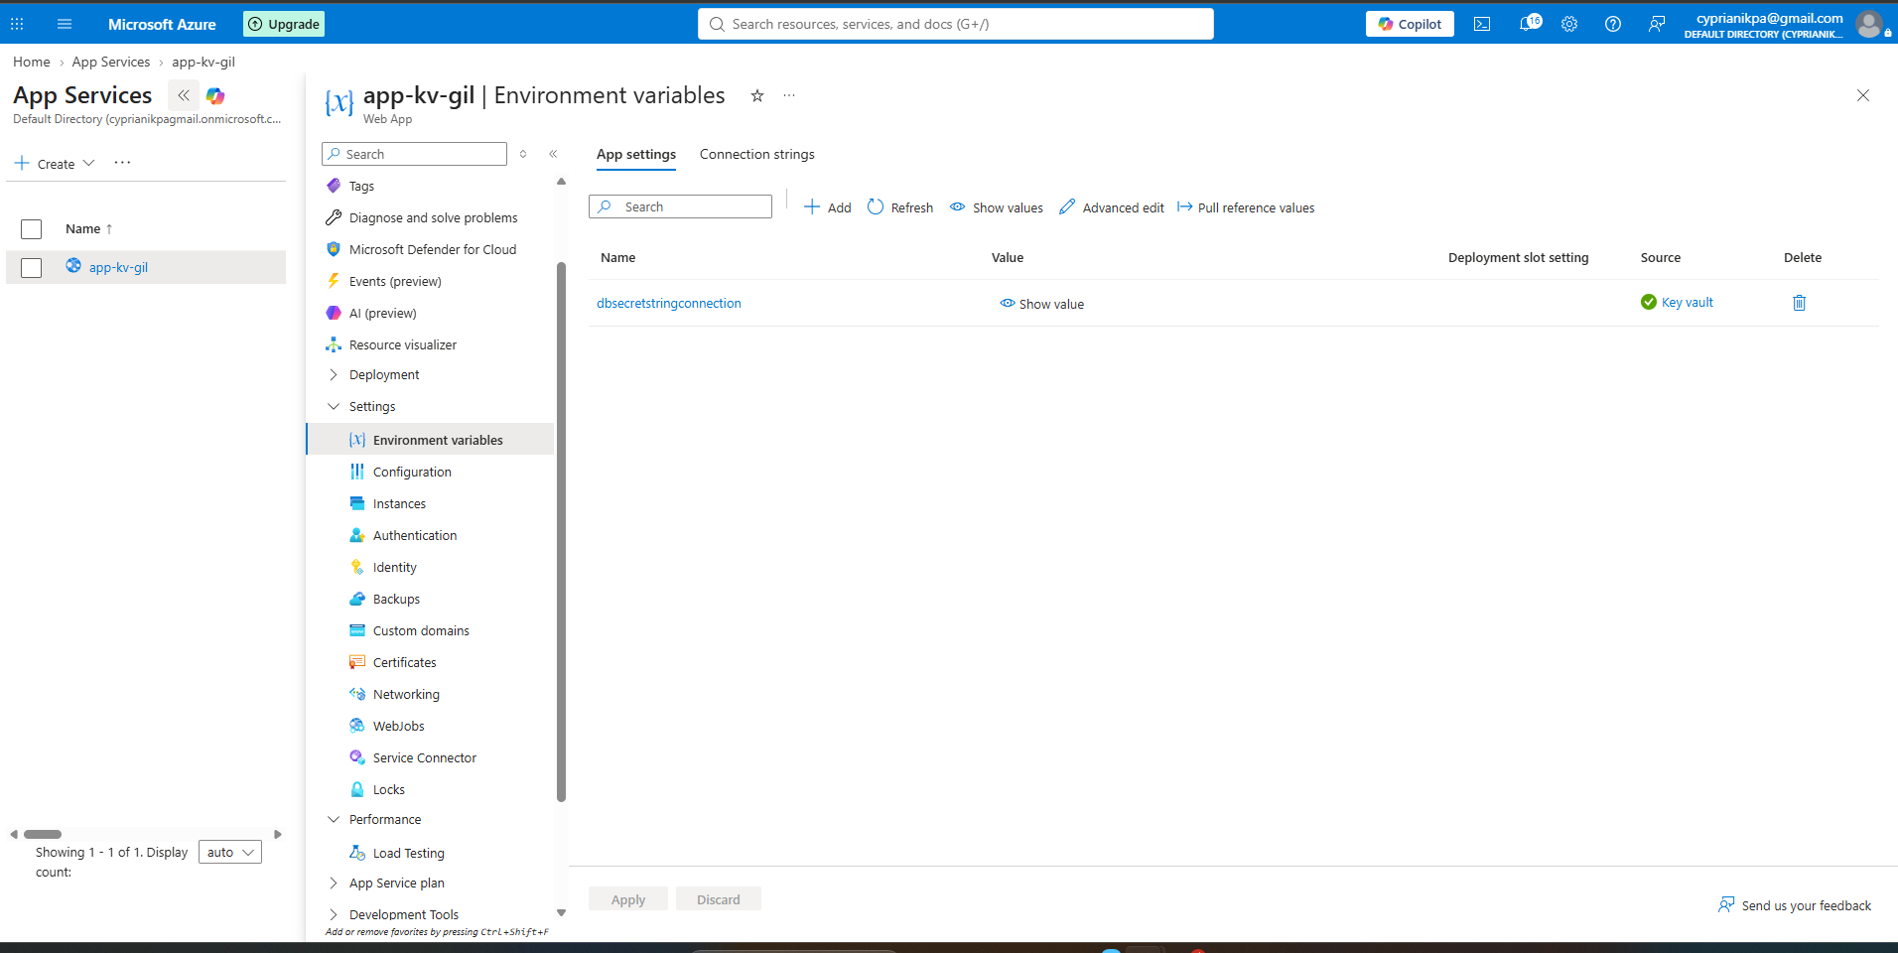
This confirms your baseline end-to-end: managed identity exists, has exactly the right role, and can pull a real secret from Key Vault — all while the vault is still publicly reachable. This is the proof point that isolates 'does the identity/code path work' from 'does the network path work', so when you lock down public access in a later step, any failure will clearly be about networking, not identity.
- Deploy a Private Endpoint into PrivateEndpointSubnet, connected to the Key Vault, with a static private IP.
- Go to your Key Vault's resource page. In the left-hand menu, click 'Networking', then the 'Private endpoint connections' tab. Click '+ Private endpoint'.
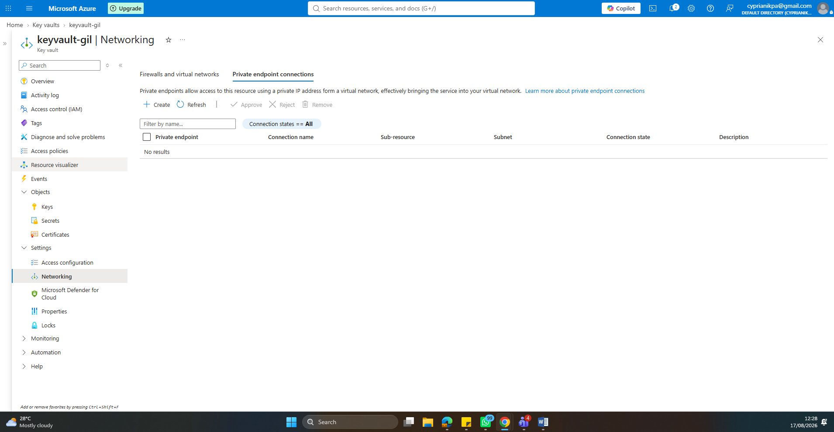

- Confirm 'Resource type' is set to 'Microsoft.KeyVault/vaults' and your Key Vault is selected as the target resource. Under 'Target sub-resource', select 'vault' (this is the only option for Key Vault, and it's what exposes the standard data-plane endpoint). Click Next
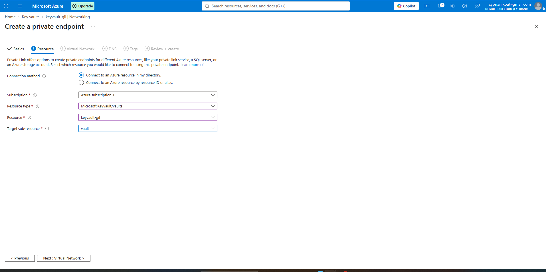
- Select your VNet ('vnet-keyvault-zt'), and for the subnet, choose 'PrivateEndpointSubnet' not AppSubnet, which is reserved for your App Service's outbound integration. This is the subnet where the actual private network interface for Key Vault will live.
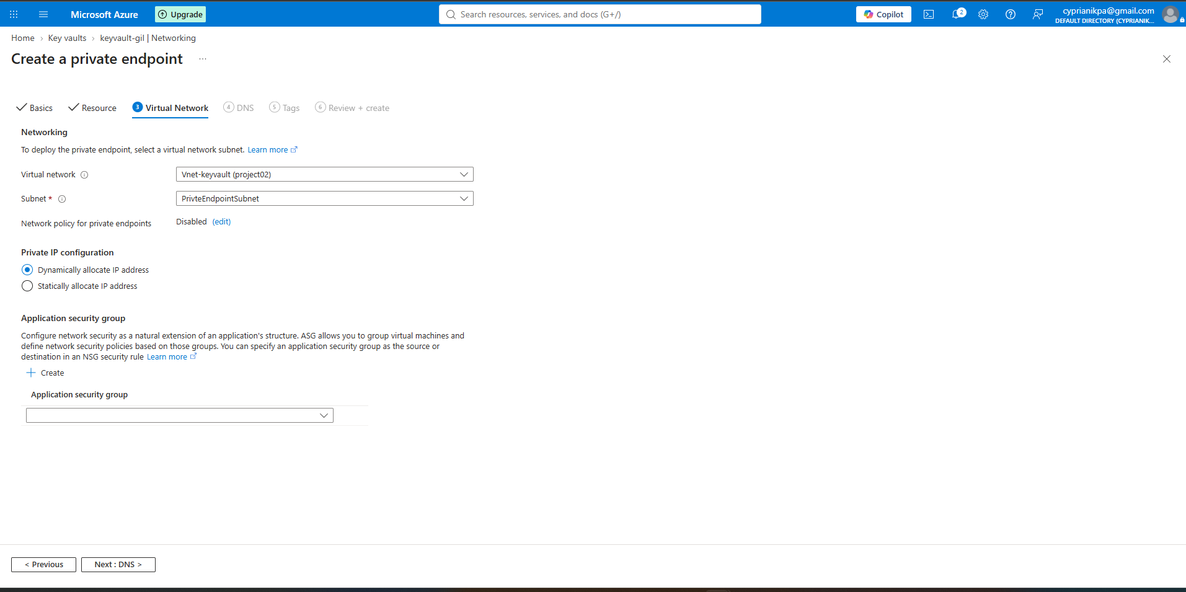
- Dynamic lets Azure pick the next available address in the subnet automatically — simpler, and fine for most everyday use. In practice it rarely changes once assigned anyway (it would only shift if you deleted and recreated the endpoint).
- Static lets you specify the exact private IP yourself (e.g. 10.0.2.4) from within your PrivateEndpointSubnet range. It costs nothing extra and takes one extra field to fill in. for this project we went with Static.
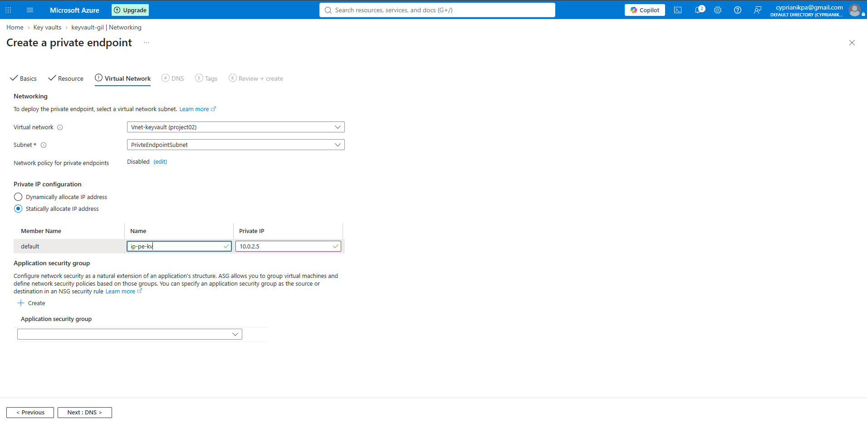
- On the DNS tab, let Azure auto-create the Private DNS Zone
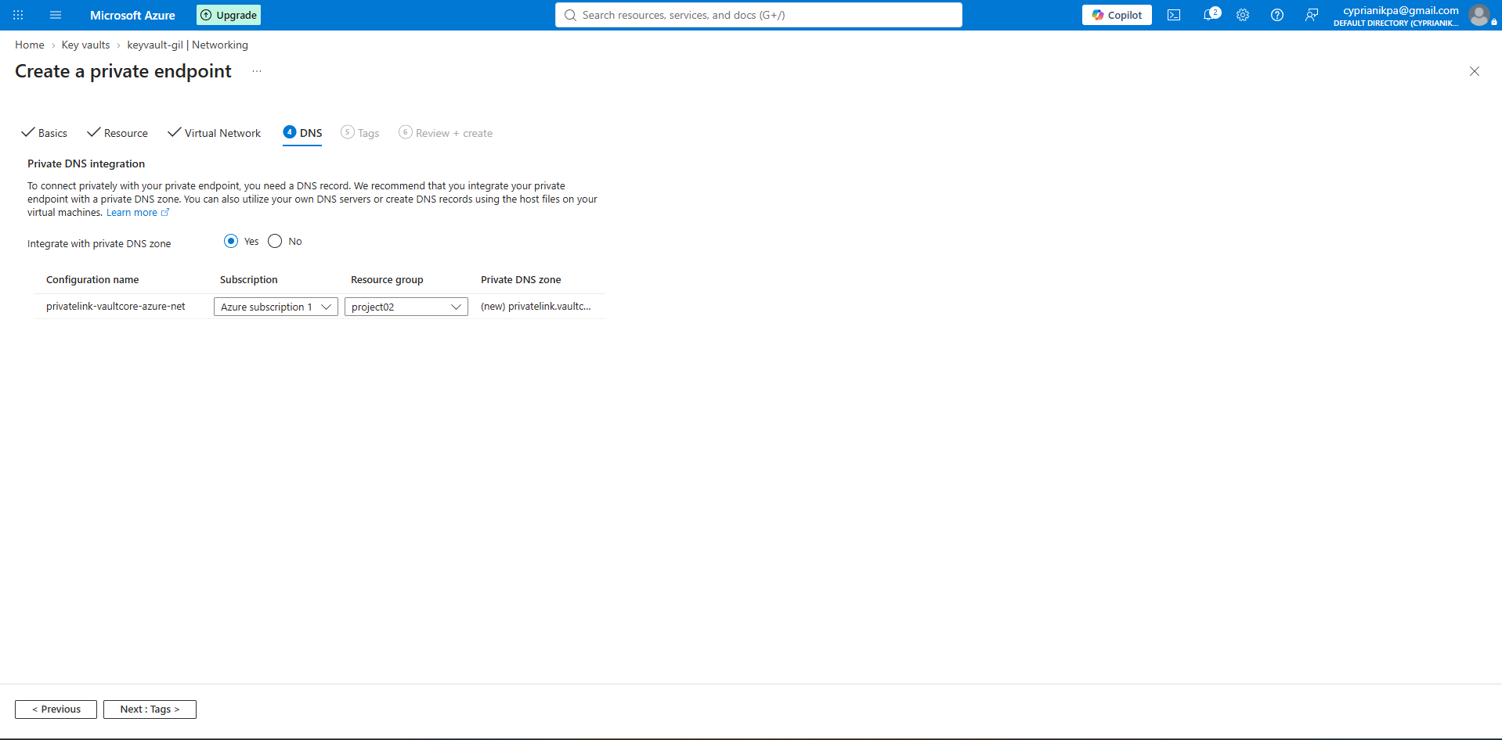
- Review and create the Private Endpoint
- Link a Private DNS Zone (privatelink.vaultcore.azure.net) to the virtual network so the vault's hostname resolves to its private IP.

- Link a Private DNS Zone (privatelink.vaultcore.azure.net) to the virtual network so the vault's hostname resolves to its private IP.
- Confirm the endpoint and DNS zone were created go back to Key Vault > Networking > Private endpoint connections. You should see your new endpoint listed with a Connection status of 'Approved' (Azure auto-approves private endpoints you create within your own subscription).
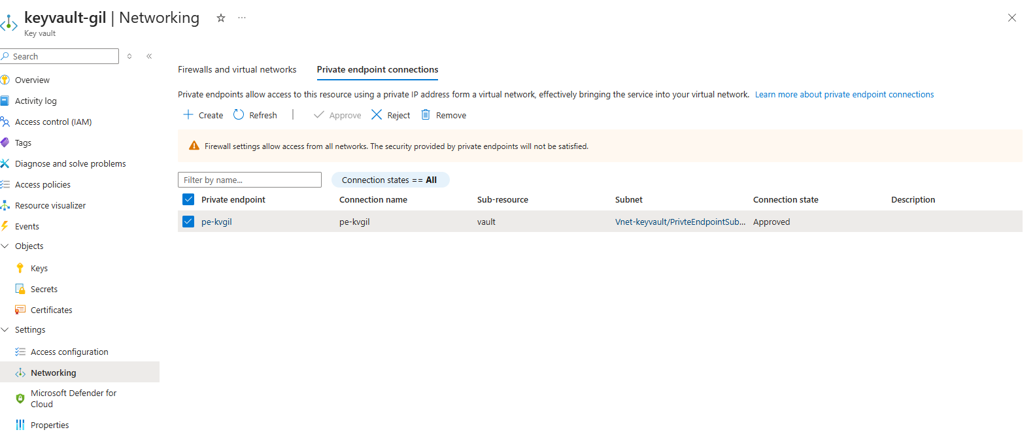
- Also check Home > Private DNS zones — you should now see 'privatelink.vaultcore.azure.net' listed, linked to your VNet, with an A record pointing to your Key Vault's private IP address.
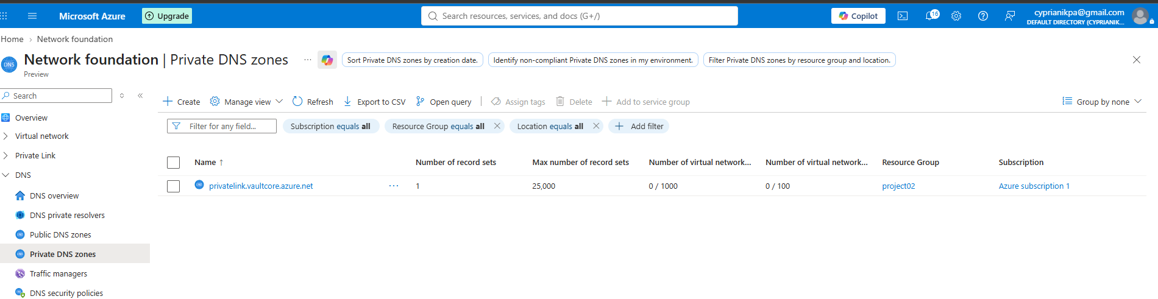
- Disable public network access on the Key Vault — the actual lockdown moment.
- Go to your Key Vault > Networking > Public access tab (or the general Networking blade). Toggle 'Allow public access' from Enabled to Disabled. Click Save at the top and confirm when prompted.
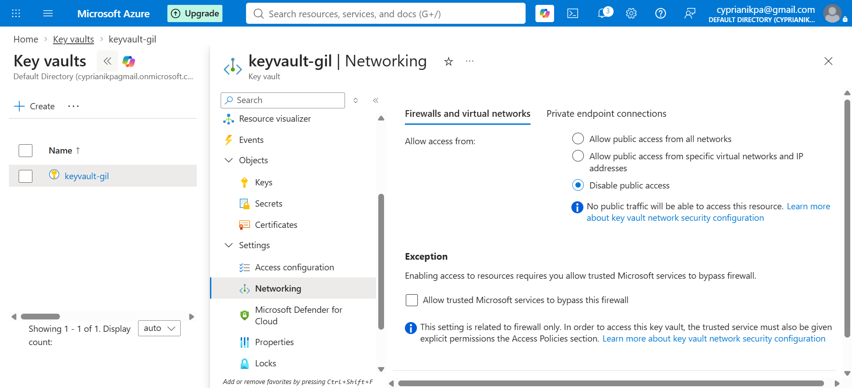
This is the actual moment the vault's public network path closes. From this point on, the only way in is through the Private Endpoint you built — which is exactly what makes the 'Zero Trust' framing of this project true rather than aspirational.
- Test 1 (the "no" test): attempt to read the secret via Azure CLI from an outside machine confirm it's blocked at the network level.
Open a terminal on your own machine (not the VM, not the App Service — your regular laptop, which has no private network path into the VNet). Run: az keyvault secret show --name db-connection-string --vault-name <your-vault-name> You should get an error like 'Public network access is disabled' or a network-related 403/connection failure. This is the proof — screenshot this error message in full.
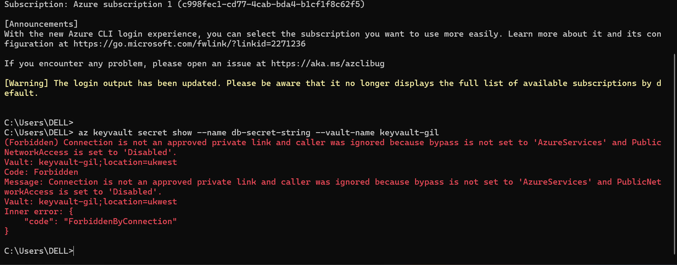
- Test 2 (the "yes" test): confirm the App Service's Key Vault reference still resolves successfully, entirely over the private path.
Go back to your App Service > Configuration > Application settings, and check the 'Source' column next to your DbConnectionString Key Vault reference. If it still shows the green checkmark, refresh the page or restart the App Service (Overview > Restart) to force it to re-resolve the reference now that the network path has changed from public to private.

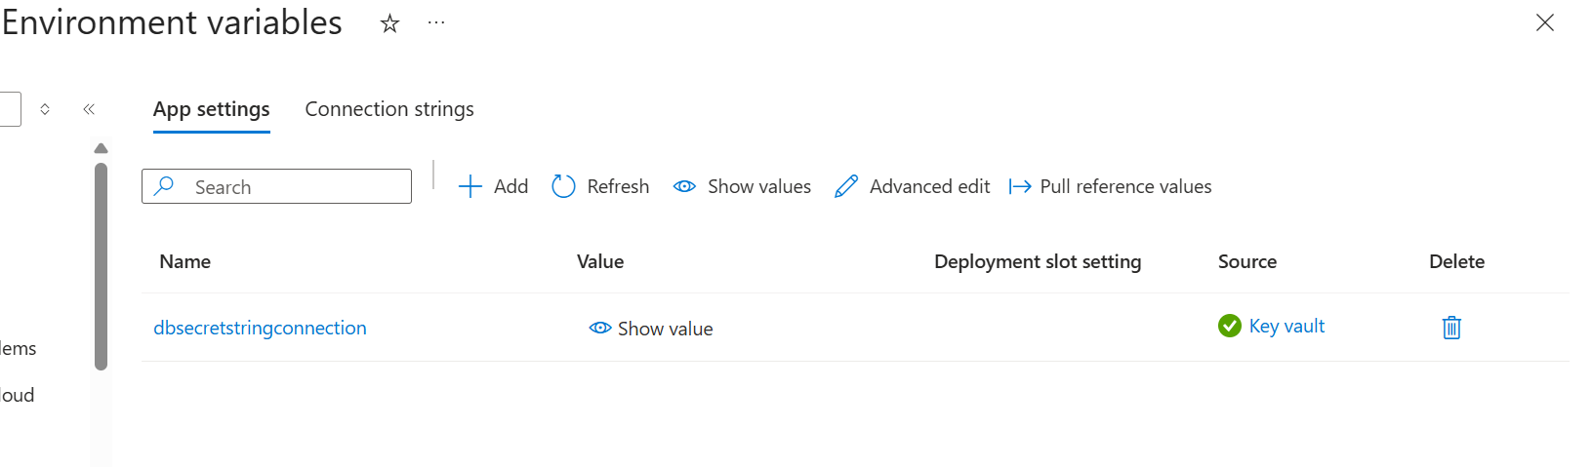
Confirm the app itself still works end-to-end
If you built any small app logic that displays or uses the secret, browse to your app's URL (https://app-zt-yourname.azurewebsites.net) and confirm it still functions normally — pulling the secret successfully, this time entirely over the private VNet path via your Private Endpoint and Private DNS Zone, with zero public exposure.
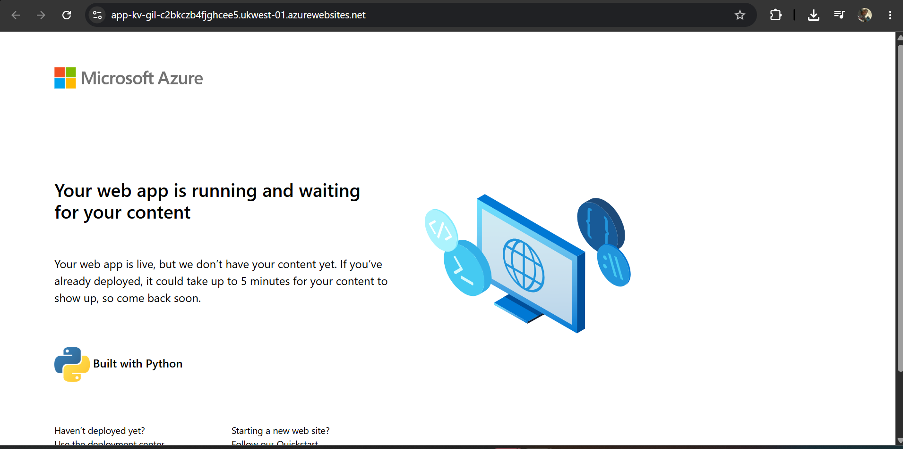

Why This Chapter Mattered
When compared side by side, what was previously an architectural concept becomes a proven fact: an unauthorized external entity, refused access out of hand, at the network level, without any equivocation. A legitimate user, granted access automatically, by means of infrastructure that was never built with the assumption of the internet being accessible. Same vault. Same secret. But two totally different results, depending on how the access request came in, thus demonstrating the very essence of Zero Trust in a tangible way.
This research responds to a crucial question: “From where can this resource be accessed?” And demonstrates that when the answer to that is “from nowhere public,” there is no need for the internet in order for a properly constructed system to work.

